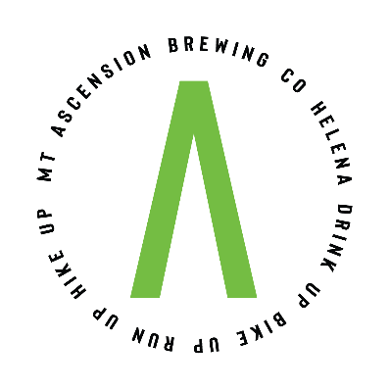
Mt Ascension Brewing Private Reservation Basic Info Sheet

Our upstairs taproom can be rented out privately from Sunday, Monday, Tuesday, Wednesday, Friday and Saturday each week. There are 73 seats available inside, with a total capacity (inside and outside) of 160 persons.

Outside beverages are not permitted. As a general reminder, Mt Ascension Brewing Co is a brewery taproom; consumption is limited to 48 ounces per person per day.

Outside food is not permitted- you must use Mt Ascension Brewing for all catering.

Decorations are permitted, but must be removed and cleaned up before leaving.
The cost of the rental for Sunday, Monday and Tuesday is $500; Wednesday is $1,000 and Friday and Saturday is $1,500 with a minimum beer/soda purchase of $500 and a minimum food purchase of $500. 20% gratuity for beer and food will be charged at the conclusion of the event. A $500 deposit is required to reserve the space, as well as a signed rental agreement.

For additional questions about reserving the space, please contact rayray@mtascensionbrewing.com

